
DIintegrator
Software Design Specification
Vesion 1.2
January 23, 2007
Revisions
Version | Author(s) | Description of Version | Date Completed
Version 1.0 | Bao Nguyen  Hien Nguyen  Le Nguyen  Thuan Tran  Tu Nguyen  Tuyen Trinh | Documentation of DIintegrator 1.6.31 | 06/06/2006
Version 1.1 | Hien Nguyen | Some spelling mistakes were corrected.  No changes in content. | 06/09/2006
Version 1.2 | Dung Dang  Tuyen Trinh  Hien Nguyen | - Module DOC811 was added | 06/29/2006

Contents
1 Introduction 1
1.1 Purpose 1
1.2 Scope 1
1.3 Definitions, Acronyms, and Abbreviations 2
1.3.1 User definition 2
1.3.2 Other definition 3
1.4 Overview 3
2 Identification of Design Mechanism 6
2.1 Language 6
2.2 DBMS 6
2.3 Components 6
3 Architecture 7
3.1 Overview 7
3.2 Modules 8
3.2.1 Dii_FileWatcher 8
3.2.2 Dii_Translator 8
3.2.3 Dii_WebService 8
3.2.4 Dii_Transform 8
3.2.5 Dii_Library 8
3.2.6 Dii_Database 9
3.2.7 Dii_ModuleLoader 9
4 Specific Design 10
4.1 Features 10
4.1.1 License Control 10
4.1.2 Web Service 14
4.1.3 Window Service 18
4.2 DIintegrator 21
4.2.1 Purchase Order 21
4.2.2 Advanced Shipment Notice 34
4.2.3 Transportation Management System (TMS) 39
4.2.4 Invoice 43
4.2.5 DOC811 46
Customer Sync 46
4.2.6 PO change status (870) 47
4.2.7 Label 49
4.2.8 Pre and Post Processing 54
4.2.9 Turn Around 56
4.2.10 Data Maintenance 57
4.2.11 Quantity Available ODBC Connector 61
4.2.12 Default Value 62
4.2.13 Log 63
4.2.14 New Transactions 65
4.2.15 Communication 66

Introduction

Purpose
The purpose of this document is to provide the description of DIIntegrator System and its design. It includes instructions of the components and features of the DIIntegrator System. It is prepared for developers who are going to develop DIintegrator System continuously.

Scope

DIIntegator System includes Client side and Server side. Client side includes one Window-based application called DIintegrator and one Web-based application called License Control. Server side includes Web Service and Window Service.
License Control is a web page to allow salesperson to place order of Diintegrator features for customers. The information about sold features will be stored in the database which is used by Window Service, Web Service at server side.
DIintegrator is used by customers-vendors- of DICentral. It is an application running on any workstation with a local database. The basic requirement is that workstation must be connected to the internet so that the map and configuration file can be loaded from server.
File Windows Service is one of the new features of DIIntegrator. It is a management tool for QA to control the DII files, Pre-process files and Pos-process files. Whenever QA want to make some changes to the Map files, they can simply modify the .dii, .pre or/and .pos file and upload it to the WebServer. The rest of the job will be run on the background.
Authentication Web Service is also one of the new features of DIIntergrator. When DIintegrator is started, username and password are sent to Web service to authenticate, then the latest maps, schema, pre, post processing as well as turn around files will be received from web server.

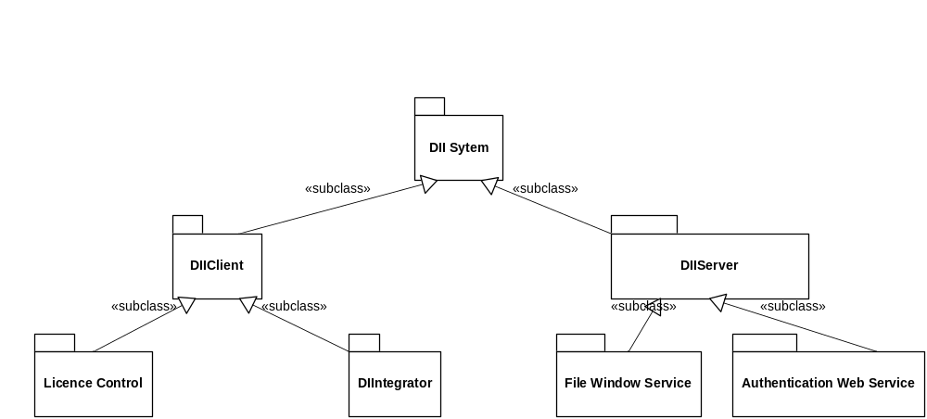

Definitions, Acronyms, and Abbreviations

User definition

Name | Description | Stakeholder
Customer/User | Anyone who buy DIintegrator and use it to process purchase order, ASN, Invoice,… and many other features of DIintegrator. | End users
Sale person | Sale person DIintegrator who sells Diintegrator for customer. He will select packages and features which customer buy on License Control web page. Information he entered will be stored in the database where File Window Service and Web Service can access. | End users
Administrator | Authorized person who manages templates and controls folders in server, maintain sever database, web service and window service. | Maintainers of the system

Other definition
HUB: Simple definition of hub is Retailer such as Walmart, JCPenny,…
VENDOR: Vendors are suppliers. They are main users of DIintegrator. In DIintegrator, Customers of vendors are hubs.
DOC850: Purchase Order (PO)
DOC856: Advanced Ship Notice/Manifest (ASN)
DOC810: Invoice
DOC870: PO change status
DOC753: Routing Request
DOC754: Routing Instruction
MapFiles:.xml files represent data frame of each DOC.
TransformFiles: .xslt file used to transform from one DOC to the other

Overview

The DIintegrator system includes the general use cases below:
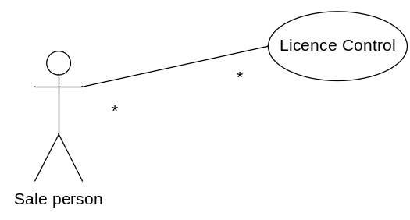

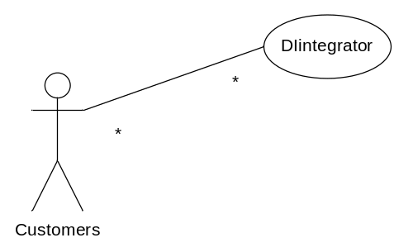

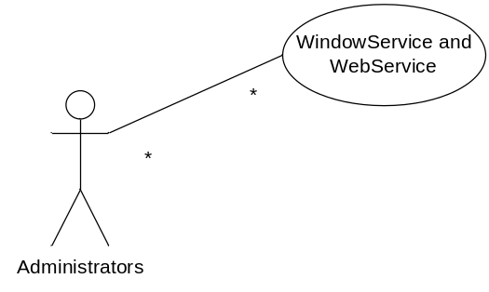
The DIintegrator system can be set up with the model below:

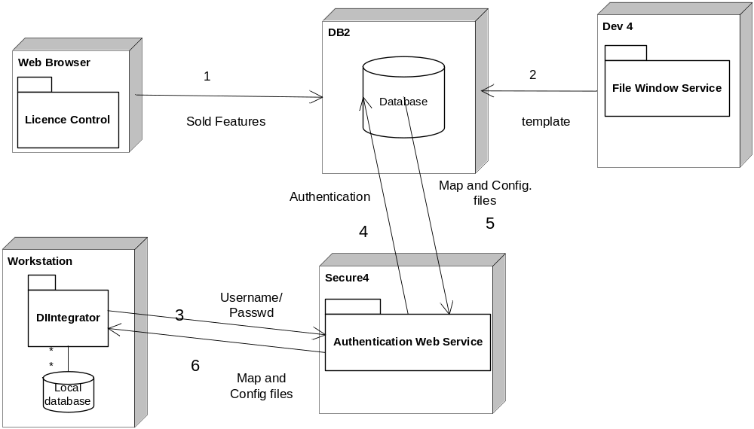

The DIintegrator system is developed replying on the workflow below:
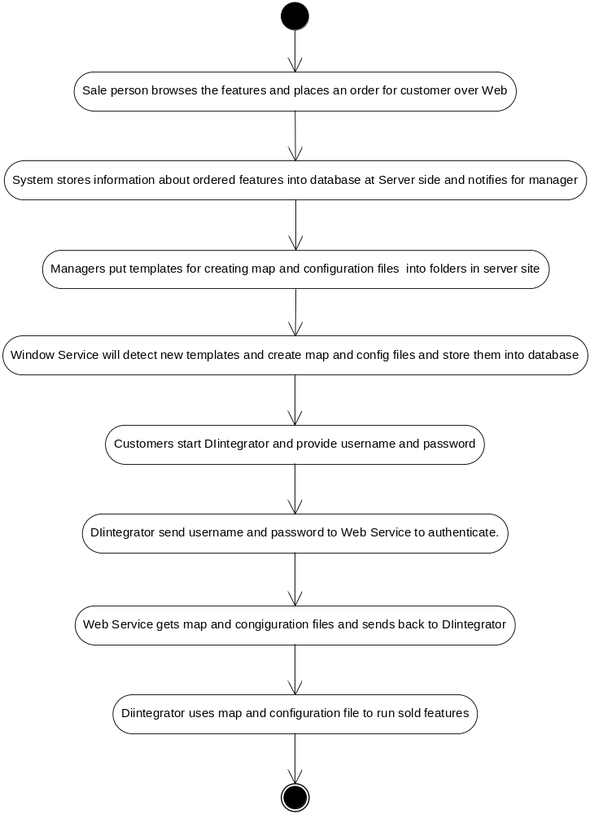

Identification of Design Mechanism

Language
Microsoft Visual C#
XML, XSLT: Xml and Xslt play a main role in implementation of DIintegrator.

DBMS
The chosen DBMS is MSDE and SQL Server. In server side, DBMS is SQL Server. Local DBMS of DIintegrator is both MSDE and SQL Server.

Components
Dev Express 3.0

Architecture

Overview
DIintegrator solution is organized into many modules. The base modules are Dii_Libarry, Dii_Database and Dii_Transform. The startup module is Dii_ModuleLoader.
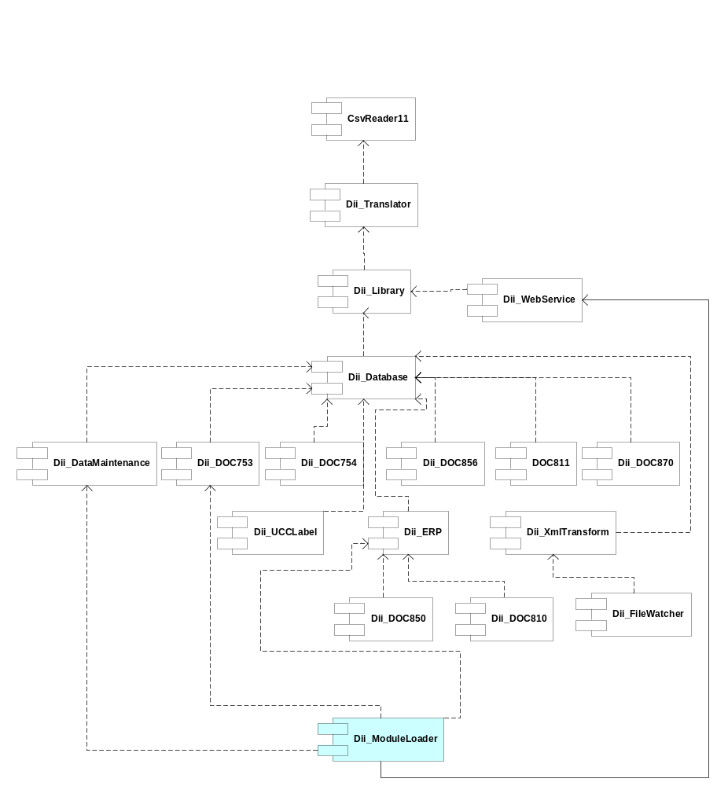

Modules
The DIintegrator solution includes many related modules, most of modules based on Dii_Library and Dii_Database. Dii_Transform is entry point of data. Dii_ModuleLoader is the central module to start DIintegrator and the bridge module connecting other modules. Dii_FileWatcher, Dii_Translator and Dii_WebService run at server side to detect updated templates then create updated map and configuration files.

Dii_FileWatcher
DOC850 is processed to create other documents such as DOC856, DOC810, etc. Turn Around tells each data column in ASN created from a specific data column in DOC850. That information and other rules are stored in templates in text files. Templates are maintained and updated by some administrator at DICentral. If those rules are changed, templates will be updated. To update those templates, administrator only needs to replace old templates by new templates in particular folders at server.
Dii_FileWatcher is a Window Service running at server to detect updated templates.

Dii_Translator
After Dii_FileWatcher detects updated templates, Dii_Translator will translate templates into map and configuration files and store into database. Map files are standard Xml files and their schemas. DIintegrator operates based mainly on these files.

Dii_WebService
When DIIntergrator is started, it is connected to server at DIcentral. WebService will be called to authenticate and then return map and configuration files back to DIintegrator.

Dii_Transform
Inbound data -Purchase Order or Routing Instruction – is downloaded from server into local workstation where DIintegrator is running; It is a text file with tab delimited format. DIintegrator processes data with Xml format. Dii_Transfrom is an entry point transforming text data into Xml data for DIintegrator.

Dii_Library
Dii_Library includes the core classes which are used many times at many other modules. XmlWorker processes all operations related to Xml processing. ModuleInfo, ModuleBase and Controller are the important classes of DIi_Library.

Dii_Database
This module includes all tasks to access to the database. Most of actions related to accessing database from other modules use classes of Dii_database . Dii_Database is a connection between application and DBMS.

Dii_ModuleLoader
Dii_ModuleLoader is startup module of DIintegrator. It includes main interfaces, forms and menus of DIintegrator. ConfigurationRenderer and ConfigurationInfo are the most important classes. ConfigurationInfo gets information and ConfigurationRenderer uses that information to render graphic and data onto the main interface of DIintegrator.

Specific Design

Features

License Control

Purpose
License control is a Web-based application. It is used to keep track the features that the user buys as well as to turn on the features in DIintegrator software.
Test page: http://windev/customer_support/cs/DII/login.asp?custid=2567

Flow Chart:
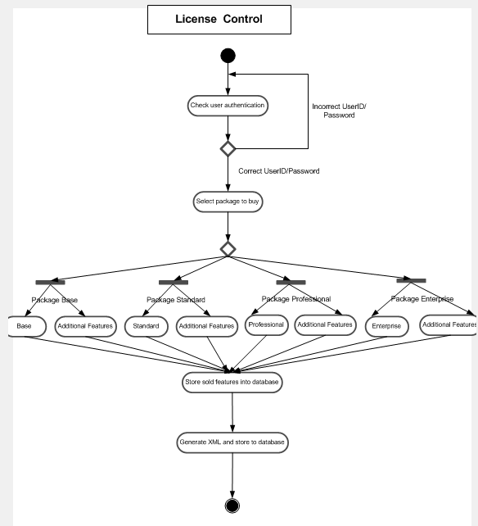

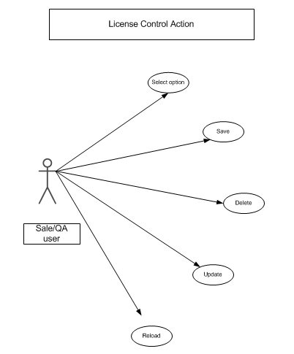

Associated Functional Specifications

Based on the previous webpage in DIcentral, we have the customerID, userID and password of a specific customer that we want to set up an account.
- Salesman or QA will help customer select features to buy.
- There are 4 main packages in DIintegrator. They are Base, Standard, Professional and Enterprise. Besides the main package, the users can buy additional features like: 870 Process Agent (Detail DII Features) or QuickBooks (Accounting Integration), etc…
- The user can upgrade the features if they pay more.
- The sold features are stored in database of DICentral.
- After order is placed, a summary page will pop up and an email will be sent to authorized person to prepare installing software for the customer (will be done in future).

Inputs
- UserID
- Password
- Hubs
- selected Feature of each hub

Processing
- Based on the purchased features, the XML string of a selected hub is created
- Program in web server will build diappcofig.xml for each customer

User Interface
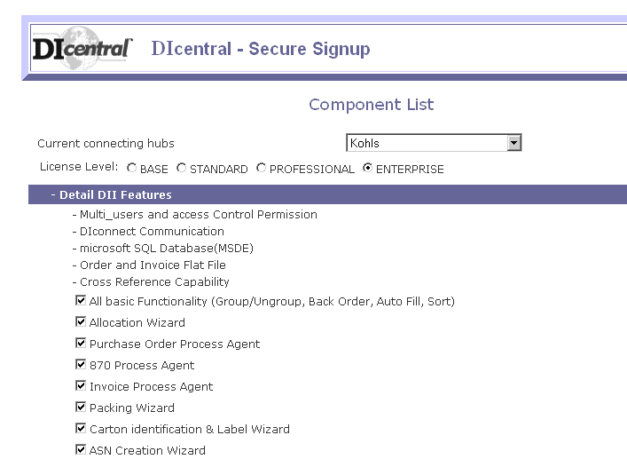

Web Service

Purpose
Web Service of DII is used for authenticating and getting the latest maps, schema, pre, post processing as well as turn-around files from webserver.

Simple Activity Flow Chart of Web Service:
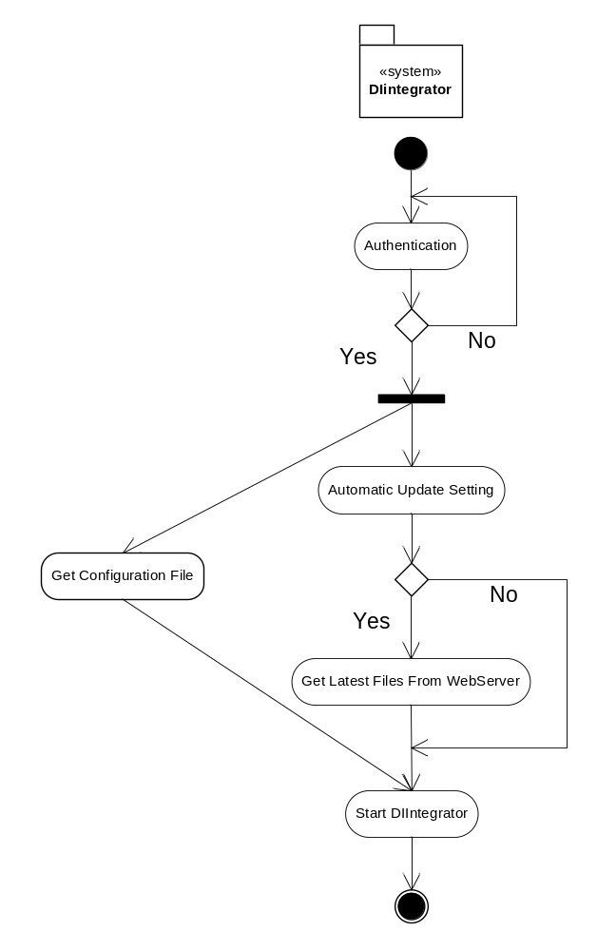

Associated Functional Specifications:
DII webservice will have module DII webservice , DII web server, DII File Watcher Windows Service and some part in Module Loader.
- DII_WebService Module:
- GetSchemaDoc.cs: this class is a proxy class between DII_WebService with web server (web references), this class can get a dynamic url.
- GetWebService.cs : this class contains all independent functions to interact with functions in Webserver.
- UpdateSchema.cs: this class contains functions to handle xml data received from web server, save data to each files and do the backup as well as check data version.
- Rollback.cs: this class is to roll back the update to the old version.
- DII_WebServer:
- GetXmlService.asmx.cs : this class contains all web service functions to query data from database and return xml data.
- Web.Config: contains connection string to database.
- DII File Watcher Windows Service: this module is running on server side to detect the new updated text map files, pre, post-processing, turn-around and use tool Dii_XmlTransform to generate Xml schema, map files set for all hubs.
- Module Loader:
- MainForm:
- getConfiguration() : this function is to get Configuration file for DII from webserber and save to diconfig.xml.
- updateMapFiles(): this function creates an instance of class UpdateSchema to perform procedure to update map files.
- upDateFile(): this function is to update file manually.
- Functions on WebServer:
- getlastedVersionByRequest:
- Input: xml data which contains filenames and versions to download from server.
- Processing: query data from server database.
- Output: xml file which contains data for files requested.
- getConfigurationFile:
- Input: UserId and Password.
- Processing: checking account, query data from server database.
- Output: xml file which contains data for files requested.
- checkAccountPassword:
- Input: UserId and Password.
- Processing: query data from server database.
- Output: boolean.
- getLatestVersionsetAllHub:
- Input: UserId and Password.
- Processing: query data from server database.
- Output: xml data file with all hubs of that account.
- getLatestMap:
- Input: UserId and Password.
- Processing: query data from server database.
- Output: xml data file which contains the latest filenames, and versions on web server.
- GetLatestVersionSet:
- Input: UserId, Password and Hub_Id.
- Processing: query data from server database.
- Output: xml data file that contains the latest file and versions for that hub.
- getHubIDs:
- Input: UserId and Password.
- Processing: query data from server database.
- Output: list of HubIDs of that hub.

Window Service

Purpose
The Windows Service is named as DIIFileWatcher. It is migrated on the production server machine. Whenever it detects there are changes to .DII files, .PRE files or .POS files, it will automatically archive the old files, make up a new version number and update the new files into Main Database. For .DII files, DIIFileWatcher also generates a pair of schema file and map file with the same version before uploading them to Main Database. By doing this, we make it possible for QA to have a central control over the business rules for each HUB in DIIntegrator.

Definitions, Acronyms, and Abbreviations

- DII File: This file contains the definition of Map file for all hubs. From each DII file, we can generate a pair of schema and Map files for each process Agent, such as DOC850, DOC856, DOC810… The file is named as the following convention:
  - Input_TransactionID_YYYYMMDDHHMN.dii for inbound file.
  - Output_TransactionID_ YYYYMMDDHHMN.dii for outbound file.
- .PRE file: This file contains the methods used for the pre load data process. The raw data will be processed as whatever defined in .Pre file before it is loaded into the DII Software. QA now can control the data loaded into DII better.
- .POS file: This is similar to .PRE file except it is for the Post – Process. Before exporting the data file, DIintegrator calls post-process to customize data as defined in .post file.
- File Version: The version is automatically calculated based on the following rules:
  - If the old file and the new file have the same date, the new version will be old version plus 0.01.
  - If the old file and the new file have different date, the new version will be the old version plus 0.1.

Flow Chart:
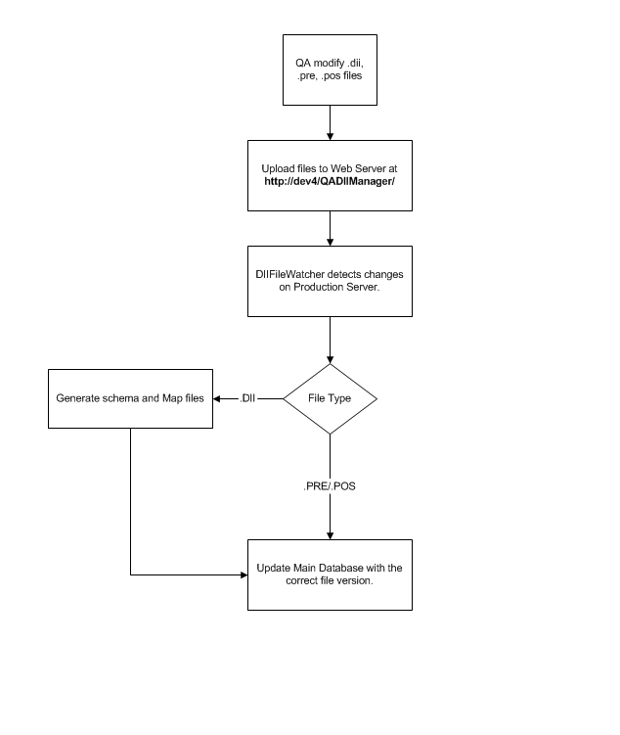

Inputs
The inputs for the software are four file type: .DII, .PRE, .POS., and .TA

User Interfaces
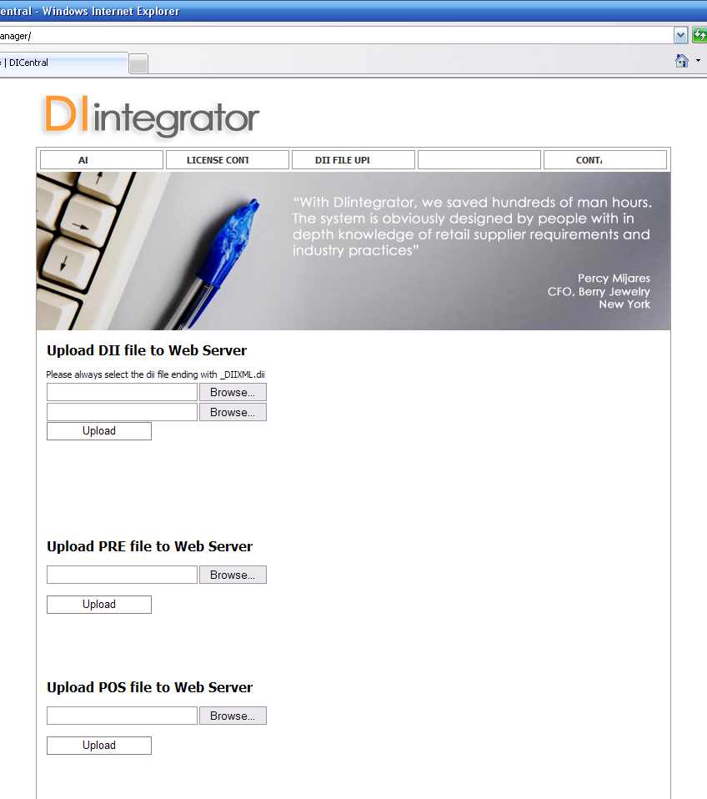

DIintegrator
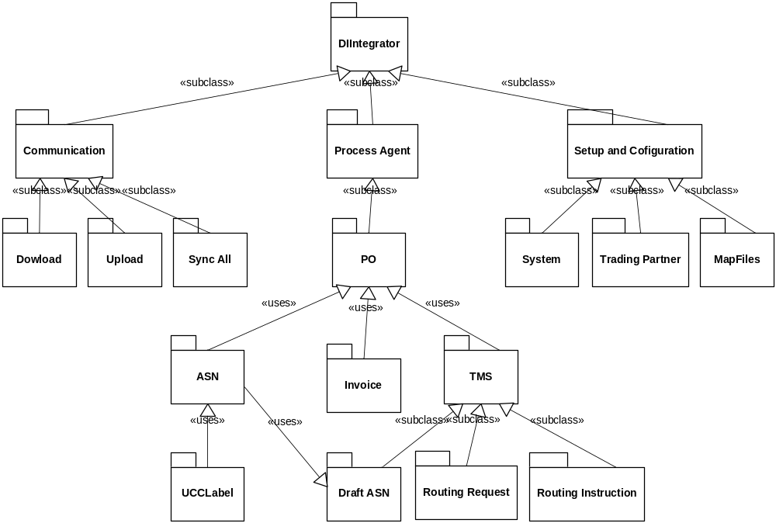
Process Agent

Purchase Order
The PO Process operates follow the chart below:
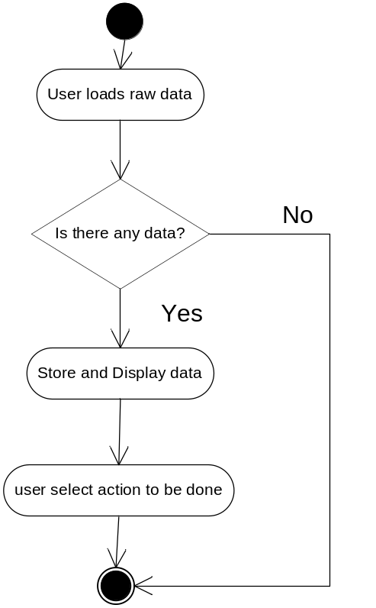
Actions can be used in PO Process includes:
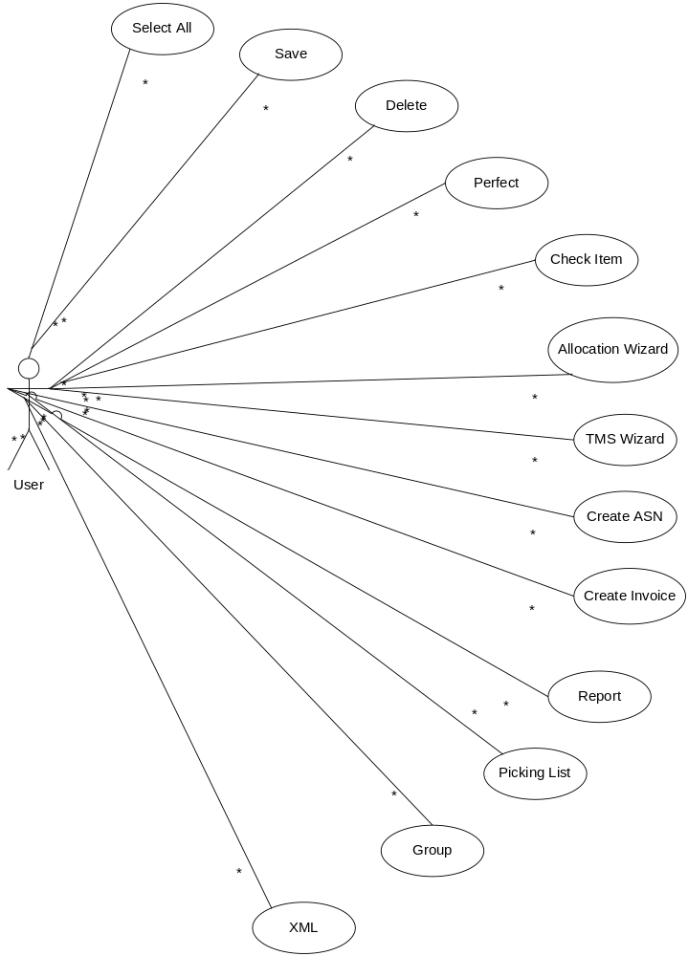

Perfect

This action scans PO data and fills in any missing information.

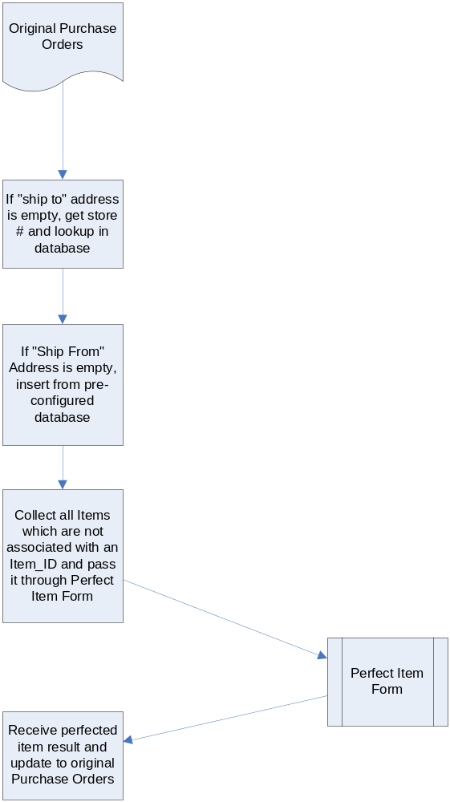

CheckItem (MatchItem)
CheckItem is used to match product qualifiers between PO from grid 850 and database
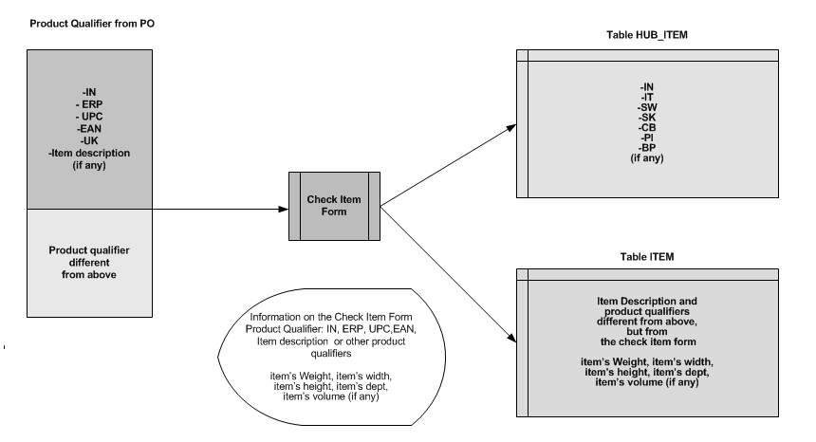

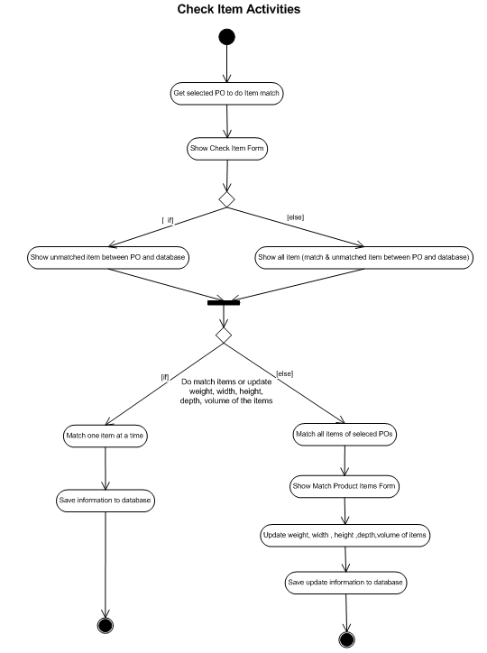
The following steps are used to match items:
- Get selected POs to do matched item.
- Extract product qualifiers from selected POs
- Compare product qualifiers between PO and database:
  - If all product qualifiers match exactly with all product qualifiers from database ➔ exactly matched
  - if all product qualifiers from PO match exactly with all product qualifiers from database and item from database has some extra product qualifiers ➔exactly matched
  - If all product qualifiers from PO match exactly with all product qualifiers from database and item from PO have some extra product qualifiers ➔unmatched
- Show all the difference and similarity of product qualifiers between PO and database on a form so the user can choose to match item or not.
- Match one item at a time.
- Match all items at the same time
Rules:
- In Check Item form users can add some information about weight, width, height, depth and volume of an item (for ASN purpose).
- Product qualifiers of an item are saved in 2 tables in DIintegrator database: HUB_ITEM, ITEM.
- 7 Product qualifiers (IN, IT, SW, SK, CB, PI, BP) are stored in TABLE HUB_ITEM, the rest (over a hundred qualifiers) are stored in table ITEM.
IN: Buyer Item No
IT:BuyerStyleNo
SW: Stock No
SK: Stock Keeping Unit No
CB: Buyer Catalog No
PI: Purchase Item Code
BP: Buyer Part No

- Each hub has different set of product qualifiers (normally less than 10 product qualifiers) to identify an item
- There are 3 groups of product qualifiers. They are global qualifiers, buyer qualifiers and supplier qualifiers.
- There are over 100 product qualifiers in X12.
- There are 3 groups of product qualifiers. They are global qualifiers, buyer qualifiers and supplier qualifiers.

Inputs
Information from selected POs

Processing
- CheckItemPO_01() (Dii_DOC850/Document.cs)
=> get selected POs to do item match
- MatchItem(System.Xml.XmlDocument item, XmlToFieldDictionary dict,System.Xml.XmlDocument masterDocHUB, System.Xml.XmlDocument masterDoc) (Dii_Database /OleDbDataBase.cs)
=>get product qualifiers of items from PO and database
- matchHUB(System.Xml.XmlDocument item,ArrayList hubQualifier, string strXML, string strHUBITEMCODE) (Dii_Database /OleDbDataBase.cs)
=> compare product qualifiers between POs and database
- matchITEM(System.Xml.XmlDocument item,ArrayList itemQualifier, string strXML, string strUPC,string strEAN, string strUK) (Dii_Database /OleDbDataBase.cs)
=> compare product qualifiers between POs and database
- CheckItem_01(XmlDocument doc) (Dii_DOC850/Document.cs)
=>build XML document to used in ItemMatch.cs
- ItemMatch.cs (Dii_DOC850/Document.cs)
=> Check item form
- ItemDevMatch.cs (Dii_DOC850/Document.cs)
=>Match Product Items form. Users can modifier weights, width, height, depth and volume of all items which have just been matched.

Outputs
Matched items in table ITEM & HUB_ITEM

AllocationWizard
The functionality of this method is to help end users update the quantity of document 850 and prepare data for creating document 870.
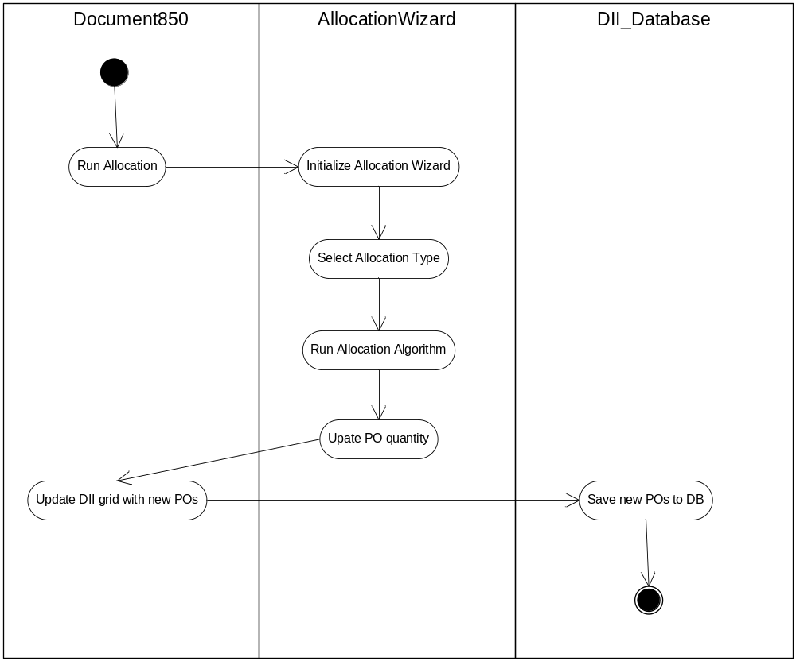

Functions

AllocateClass()
The functionality of this method is to run the allocation based on the class of store. Each store is assigned to a class. Based on of the priority of the class that store is assigned to, quantity will be assigned to stores.

Inputs
Available quantities of Pos and store list.

Processing
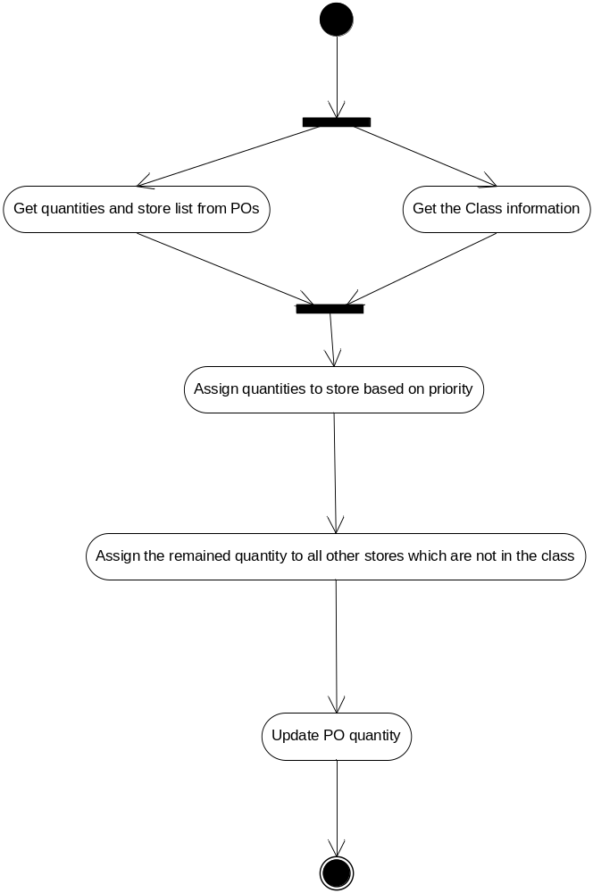

Outputs
Updated Pos with new quantities

TMS Wizard
TMS Wizard includes a sequence of steps to create ASN from DOC850 and DOC754. It is explained in detail in section Transportation Management System.

Create ASN
Data of DOC856 will be turned around mainly from DOC850. One ASN can be created from one or more POs. ASN which is created from many POs is called bundle ASN. The structure of ASN is shown in Golden Standard Specification.

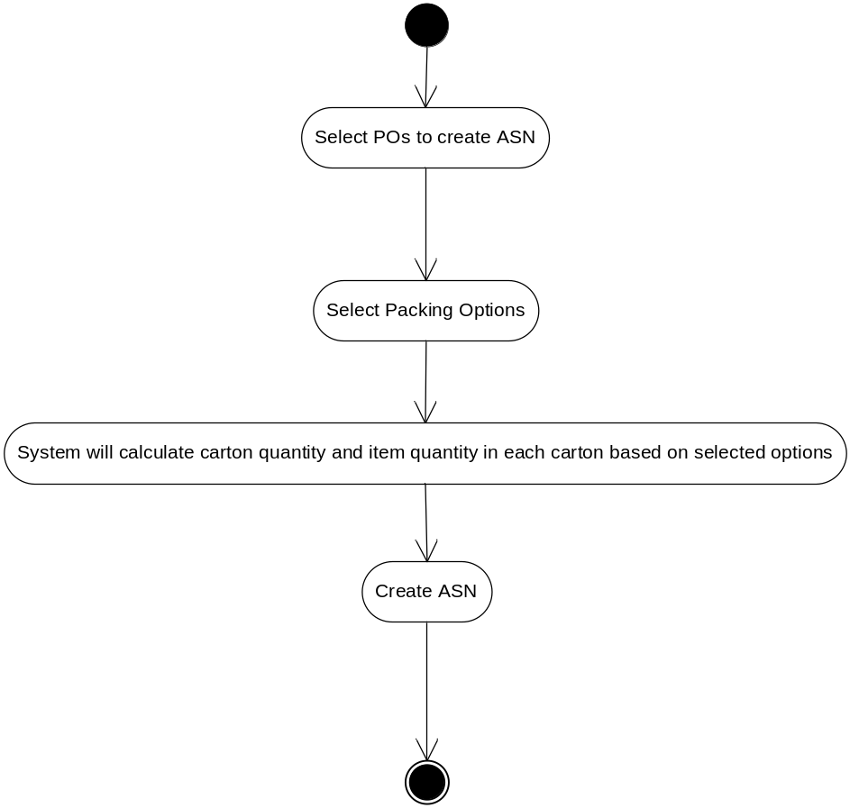
Packing Options is one of the most important steps in creating ASN. When users select packing options, they select the appropriate way in which cartons to be created in order to pack items.
For examples:
(1)Pack all items in one carton.
(2) Pack one item (UPC code) per carton (flexible UPC quantity in each carton).
(3) Pack one item (UPC code) per carton (same UPC quantity in all cartons).
(4) Pack multiple items (UPC codes) per carton (flexible UPC quantity in each carton).
(5) Pack multiple items (UPC codes) per carton (same UPC quantity in all cartons).
(6) Pick & Pack 1 (Pack customized quantities and cartons)
(7) Pick & Pack 2 (Pack customized quantities and cartons; customized default pack quanties for all cartons)
(8) Super Pack (Pack mixed UPCs per carton, customized Pack Quantities)
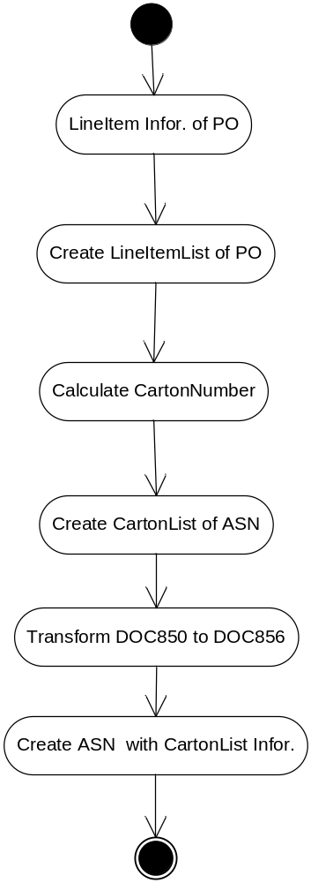

Group
The Group feature provides a way to group transactions.
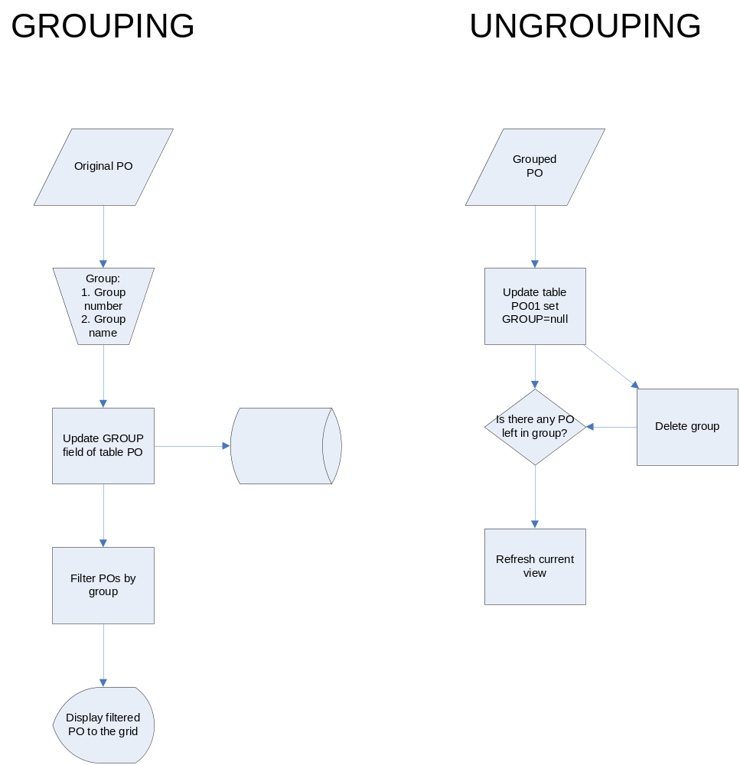

Back Order
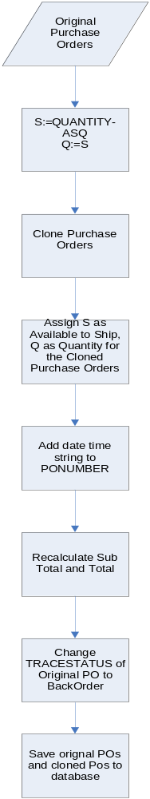

Advanced Shipment Notice
From Purchase Order, we turn them into ASN Manifest (DOC856). Dii_Doc856 will handle all functions and reports available for ASN Manifest.
The action in ASN module includes:
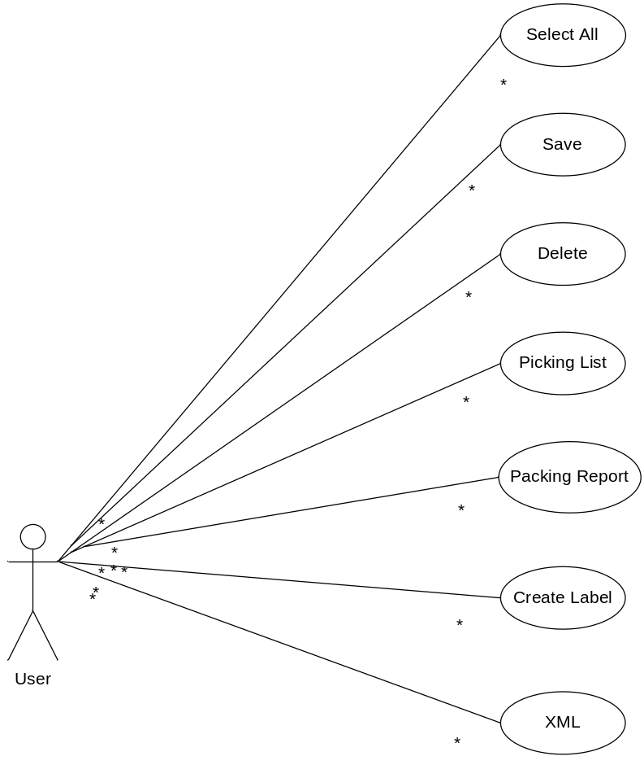

Select All
Select all of the ASN Manifest on grid.

Save
Save modified ASN data into Database

Delete
Delete ASN Manifests from gridline. This action will remove these records from database permanently.

Picking List
The picking list is one form of report for ASN. It is a two-dimension matrix table in which row is the PO Number, Store Number, and DCNumber; column is the UPC Number andProduct Code. This is a useful tool for customers to pick out the quantity shipped for each product to each store or DC. The layout of Picking List is as follows:
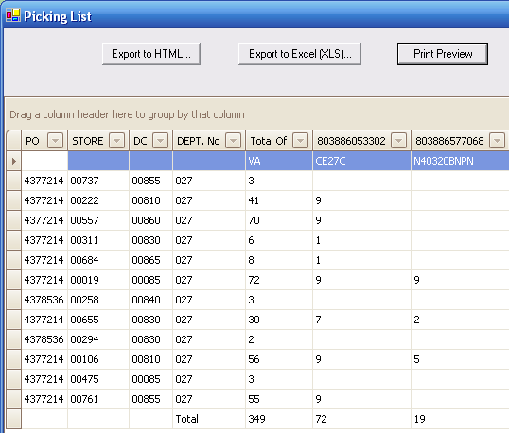
- Classes used to develop Picking List:
  - PickListProcessor.cs
  - PickListForm.cs
- Flowchart of making PickList process:
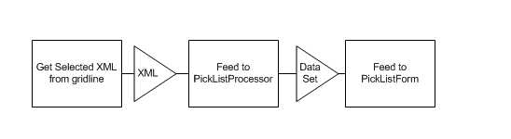
- Algorithm for each class:
  - PickListProcessor.cs:
The main method is DatasetGenerator()
To make sure that the results printed out on the Picklist are sorted alphabetically, we define a SortedList of ASN number and use it as a key for other HashTables: StoreHash (store number), DeptHash (Department number), DCHash (DC number)… Then from the XML Document of all selected ASNs, we read the data and feed these Hash Table and Sorted List.
After feeding all of these HashTable and SortedList, we read them back with ASN number as a key. From these values, we dynamically generate a Dataset for PickList.
The DatasetGenerator() method will return the result Dataset.
  - PickListForm.cs:
The PickListForm contains a Gridcontrol and a Gridview. We use the resulting Dataset from PickListProcessor class as a Datasource for the Gridview. Besides, in the class constructor, we read the first row of Dataset and dynamically change the header of the Gridview. Therefore, the Gridview will show with correct Column names.

Packing Report
Packing Report in DOC856 Module is an important report for Shipment. These reports are designed in detail so that it shows all of the needed information, such as: ShipFrom, ShipTo, Carrier, BOL Number, Total Shipped… The reports are separated into 3 different types: Carton level, Order Level and Shipment Level
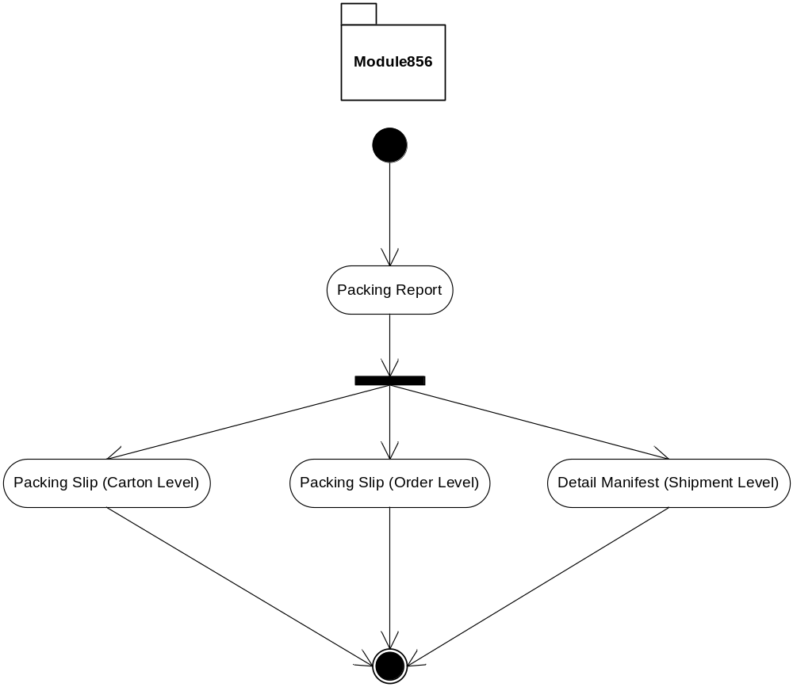
Reports:
- CartonContentReport.cs: display detail of a carton.
- CartonContentReport1.cs: under development.
- PackingSlipPO01.cs : regular packing slip with detail of an order.
- PackingSlipPO.cs: change structure of Doc856.xsd to move LineItems level to PO level to count total cartons.
- PackingSlipPO2.cs : different format of PackingSlip01 for specific hub.
- DetailManifest.cs : display detail of an ASN.
- PackingReportSelectBase: this class is a base class for PackingSlipReportSelect1 and PackingSlipReportSelect2 to work with Repx file.

Create Label
This will call the CreateUCCLABEL_01() method from Document.cs to generate the UCCLabelData for Dii_UCCLabel module.

XML
Get the whole XML document on the grid.

Send
Send the selected ASN in ASCII format to outbox.( C:\Temp\Outbox\856\HubID)

Transportation Management System (TMS)
In DIintegrator, TMS includes some documents: DraftASN, Routing Request, Routing Instruction, and ASN. In TMS, ASN is created not only from information of Purchase Order but also from Routing Instruction(754). Routing Instruction is inbound data. To get Routing Instruction, Routing Request (753) must be sent to HUB then HUB will send Routing Instruction back to be loaded into DIintegrator. There are some specific rules about Routing Request and Routing Instruction which will be explained in detail.

Flow Chart:

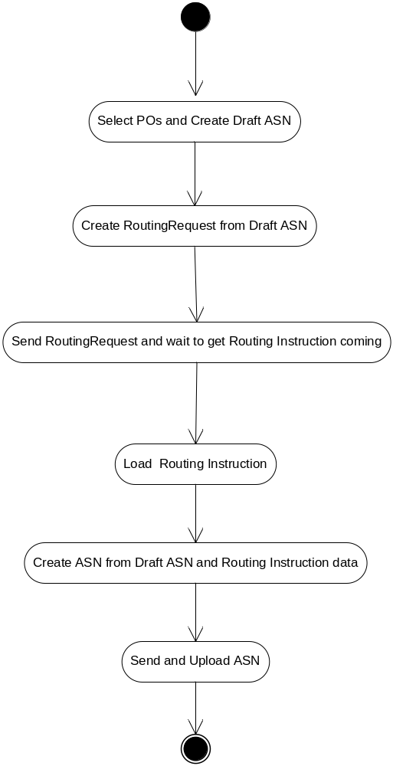

Associated Functional Specifications

Based on the flow chart, TMS can be processed in two steps:
Step 1: Load 850 ---------→ Draft_ASN----------→ 753------→ Send 753
Step 2: Load 754------------→ Create 856 from data of Draft_ASN and 754

Draft_ASN:
Creating DraftASN from 850 is the same as creating ASN from 850

Rules:
One PO to one Draft_ASN

Routing Request (753)
Routing Request is created from DraftASN. Information about turn around of 753 from 850 is shown in Golden Standard Specification.
Rules:
- One Draft_ASN to one 753.
- Routing Request must be created in range of 2-3 days before ShipDate.
Code: Dii_Doc753\Document.cs\ LoadDOC753_01(XmlDocument _doc)
RoutingRequest module includes the functions below:
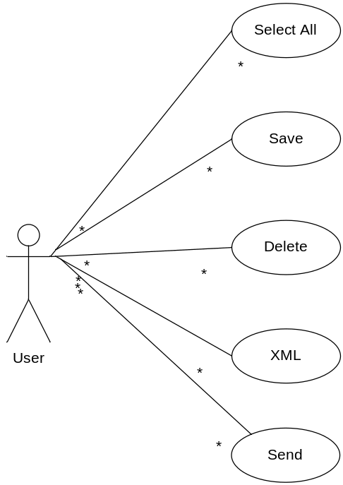

Functions:
- Using xslt to transform 856 to 753
- Get Default Value
- Validating data before creating 753
- Save into database
- Change status of Draft_ASN

Send Routing Request
Rules: 753 flat file must be sorted by SHIPTOCODE
Code: Dii_Doc753\Document.cs\SendDOC753_01()
Dii_Doc753\Document.cs\SendDOC753Wizard_01()
Functions:
  - Sorting 753 by SHIPTOCODE
  - Validating 753 before sending out
  - Send753

Routing Instruction
After Routing Request was uploaded from DIintegrator and sent to HUB, Routing Instruction will be sent back. Loading 754 file into DIintegrator is similar to loading Purchase Order, 754 data is saved in table RoutingInstruction in DIintegrator database
Rules:
754 is loaded only if corresponded 753 existed. It means each 754 has the same PONUMBER and RoutingRequestControlNumber as those of 753.
The HubID in flat file 754 has the format like in the picture below. This is a list of hub separated by $ sign. One of the conditions for the flat file to be loaded is that hub ID of loading(754) hub must match with one of the hub ID in the hub list.
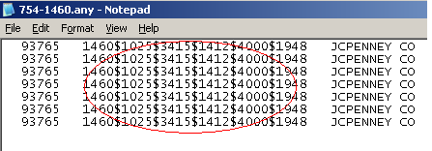
RoutingInstruction module includes the functions below:
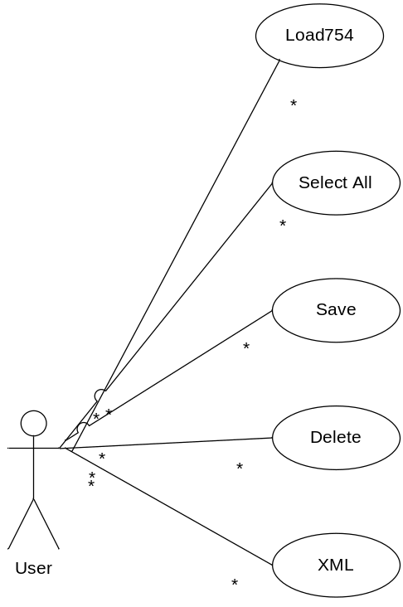

Creating 856 from Draft_ASN and 754
Rules:
Draft_ASN may create bundled ASN based on SHIPTOCODE and LOADNUMBER (LoadPlaningNumber). Draft_ASNs which have the same SHIPTOCODE and LOADNUMBER will be created into one ASN.
Information about columns of 754 which is used to create ASN can be found in Golden Standard Specification.
Code: DII_Draft_ASN\Document.cs\CreateDOC856_01()

Invoice
This module processes all the functions related to Invoice document. The main function of this module is CreateDoc810.

Flowchart
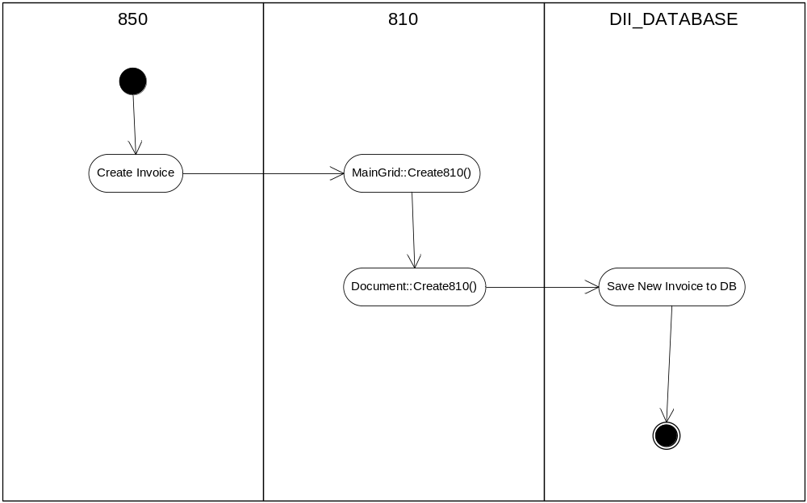

Functions

CreateDoc810

Introduction
The functionality of this function is to create new Invoice document based on the Doc850 document (input).

Inputs
Document 850
Processing
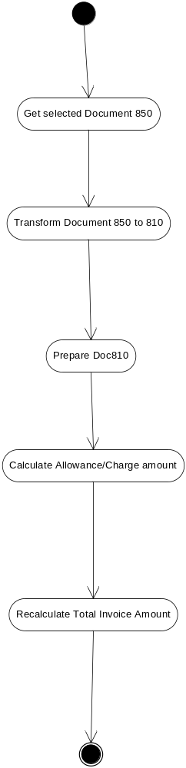

Outputs
- Document 810

DOC811
This module is used to get invoice information from QuickBooks (the selected information based on Gold Standard of DOC811) and show in DOC811 grid for the user viewing or sending that information to flat file.

Functional Requirements
In DOC811 the user can do the following things:
- Select all invoice lines.
- Delete certain invoice lines in grid811.
- Send invoice information to flat file.
- View invoice information under XML format.
- Click Connect QuickBook to reload DOC811 from QuickBooks.

User Interface
Document 811
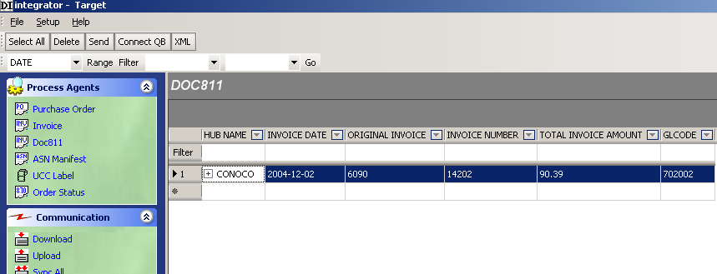

To view DOC811, user needs to do Customer Sync first. (Setup->Trading Partner->Customer Sync)

Customer Sync
Purpose:
To copy customer’s ID from QuickBook database (accounting system) to STORE table in DIintegrator database. Those IDs will be used in QuickBook integration functions.

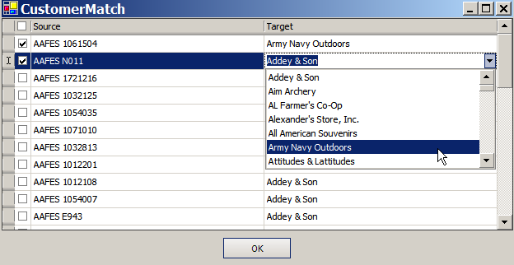

Rules:
  - Stores of current hub will be loaded on form together with customers from QuickBook database
  - QB customer’s ID will be saved according to the selected store
  - Sync All: All stores of current working hub will be shown on interface together with customerfrom QuickBook database;
  - Sync New Stores: Just stores without QuickBook information will be loaded.

Functions:
MatchCustomer_01 (bool condition):
  - true: Sync all
  - false: Sync new stores

PO change status (870)

Purpose
To create and manage the document 870 (PO change status)

Flowchart
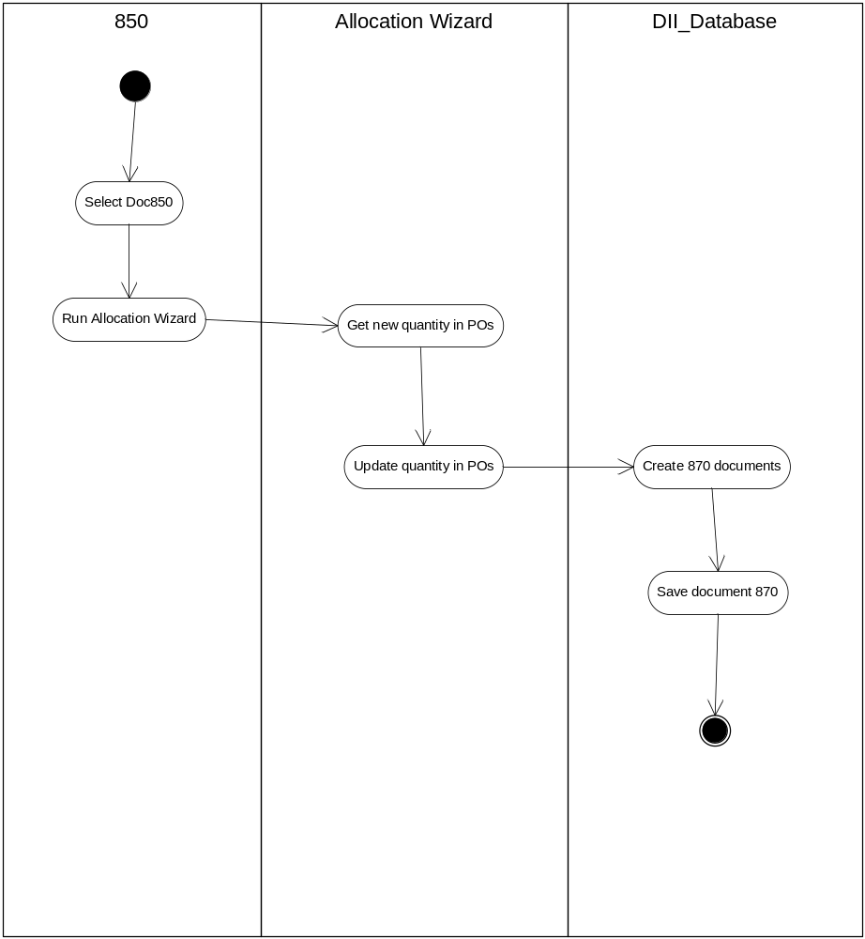

Functions

Create870()
The functionality of this method is to create the new document 870 from the result of Allocation Wizard. After running the Allocation Wizard the quantity of the PO may be changed. These changes will be reflected in document 870.

Inputs
The adjusted document 850 (after running Allocation Wizard)

Processing
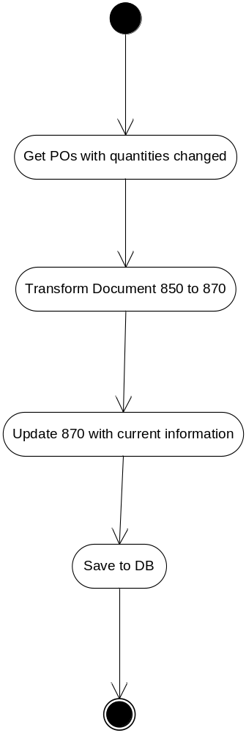

Outputs
Document 870

Label
The Dii_UCCLabel is one of several modules in DIIntegrator Software. It holds the responsibility of generating the xml structure from DOC856 and populating these data on the gridline. Users can easily select and print labels from the grid. The whole process is done automatically.
This module will handle the process of printing UCCLabel. From DraftASN or ASN Manifest, users can create labels by simply clicking on one button. After creating the labels, users can manipulate the data directly on the gridline. When users are ready, they can select the printing options and print labels as they want to.
Definition
- Label template: the template which determine how the label will look like. This file locates inside each Hub folder. The label has the format: label_856_[labeltype].txt where label type is index starting by 1.
- Label type: type of label according to each hub. For example: 4 x 6 label, 5 x 7 label, Ship Direct to DC Label…

Flow chart
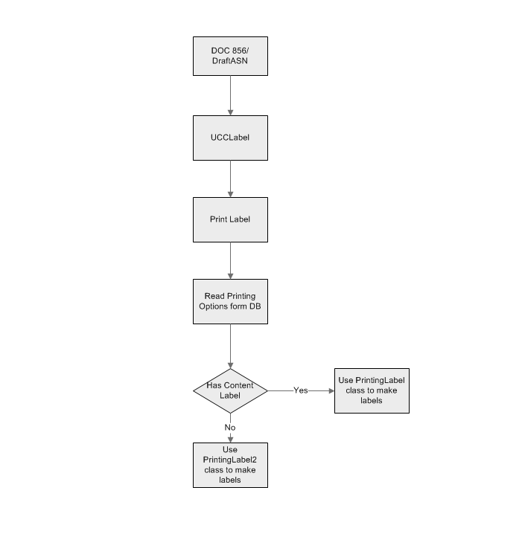

Input
The input for UCCLabel is the transformed data form DraftASN or ASN Manifest (DOC856). The transformation is done through a transform file named as DOC856toUCCLabel.xslt. This file is stored inside each hub folder. The data loaded onto the grid is determined in the map file named: UCCLabelMap.xml.
Functions
Label module includes the functions below:
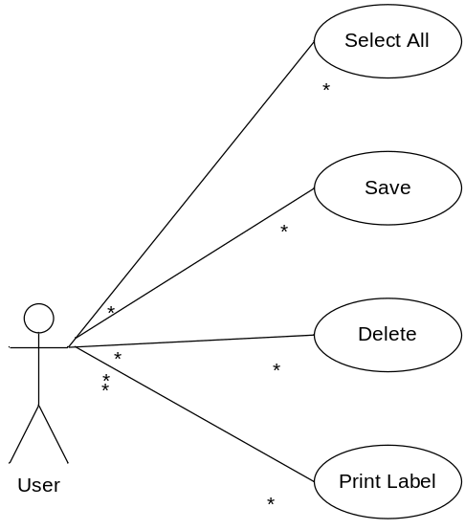

Select All
Select all of the Label Data on grid.

Save
Save modified data into Database

Delete
Delete Labels from gridline. This will remove these label records from database. The information will be removed permanently.

Print Label
This will bring up printing options. Users can choose which type of label they want to print. When finish, users can see the reviews of all of labels they printed.
- LabelInfo.cs: This class will get all of the information of a label from table Label_Sub in Database. This information includes: mapID, hubID, number of Sub Label, Sub Label Description, HasContentLabel… Therefore, it will be an object that holds all of the need information for a label.
- LabelSelection.cs: This class will call an object of LabelInfo which contains information about labels for a specific hub. From this object, it knows how many label types belong to current hub. Then, it will dynamically create a label selection form for users to select the printing options. Following is an example
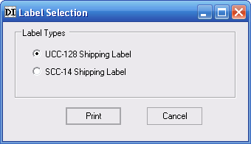

- PrintingLabel.cs: This class will load the XML Data from user’s selection on the grid view when they choose to print labels. The two main files that this class will use to generate the labels are: UCCLabelMap.xml and the template file (ending with .txt). These two files are specific for each hub and located inside the hub folder.
  - UCCLabelMap.xml: Store the information which should be displayed on the grid view. Beside, it also stores the field that needs to be displayed on the label. Whichever xmlNode we need to show on the Label has an extra tag: g:label="Column(Number)". This Column number is in the label template file.
  - Label_856_Number.txt: This file stores the template of the label. It defines how the output label will look like. In the template, we will see the following tag: Column(Number). These will be replaced by the corresponding value defined in the UCCLabelMap.xml.
- PrintingLabel2.cs: This class is similar to PrintingLabel.cs except that it has the definition to print out the “content” label.

Database
Table Label_Sub:
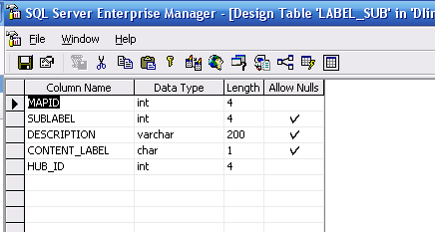
This table stores all of the information about a label. This information can be downloaded from the same table on production Server.
SubLabel: Index of Label Type
Description: Description of each label. This is the printing option when users choose to print label.
Content Label: Yes if this type of label has a content label with it.
Hub_ID: The Hub ID which each label belongs to.

Setup and Configuration

Pre and Post Processing

Purpose
To give more control to QA group in controlling data in and out the DII. This module handles data in ASCII format before and after DII (XML format).

Flowchart
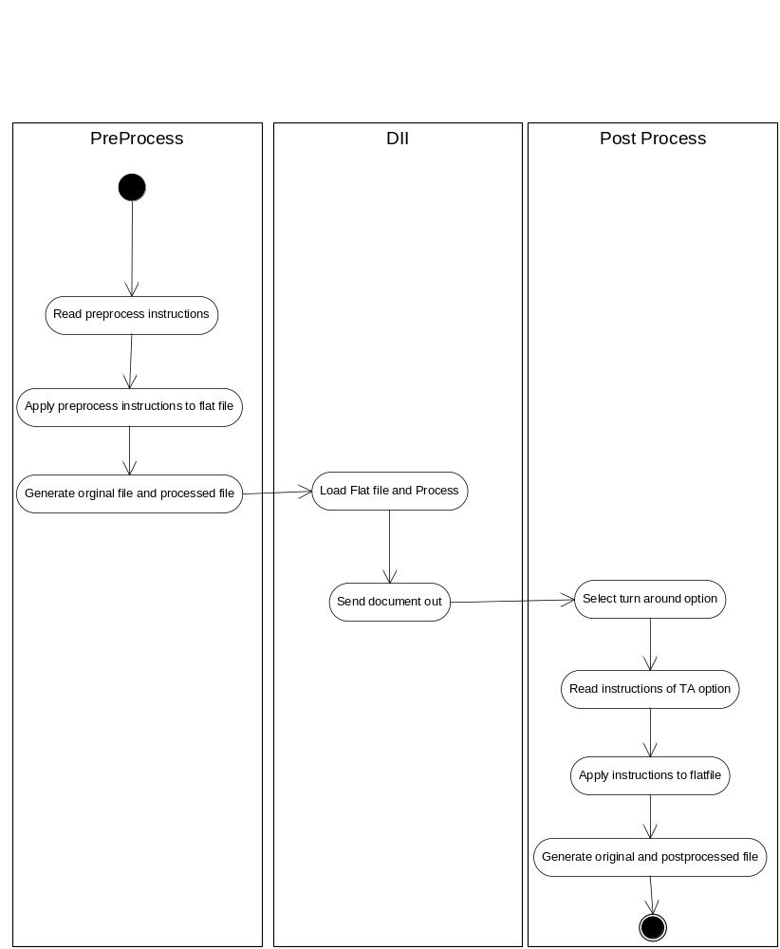

Functions

InstructionProcessor()
The functionality of this method is to read all the instructions and process as designed.

Inputs
The instruction collection string.

Processing
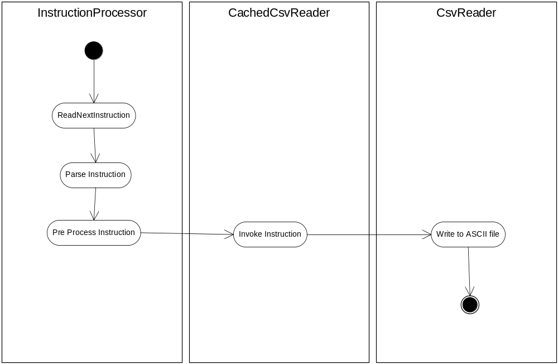

Outputs
The ASCII files as the result of pre or post process.

Turn Around
Turn Around feature will read template .TA to determine which options should be selected so that DIintegrator can do the appropriate Post Process which is corresponding to the PapId in both .pos file and .TA file.
Output: Instruction set from which Post Processing will use.
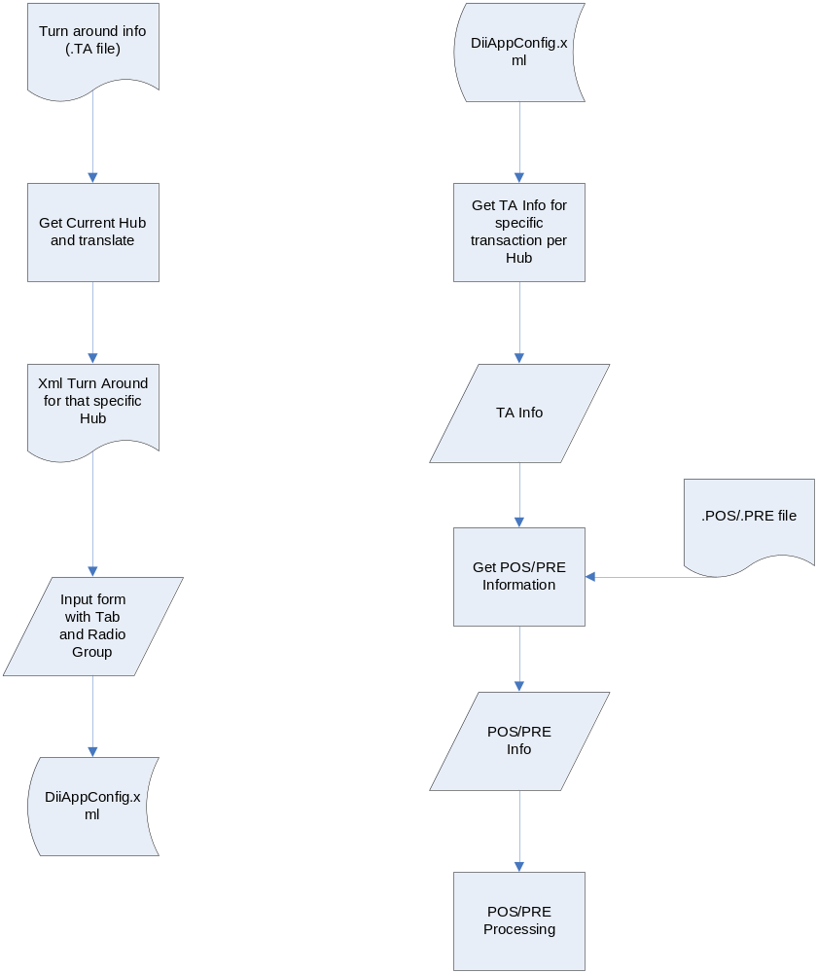

Data Maintenance
DataMaintenance module is used to keep track information of hubs, items, and stores into database.
There are five main forms in DII_DataMaintenance:

Form Hub
Notice: Column Send PO in form hub is used to set that hub for changing receiverID purpose. For example: if Hub_ID (1060), Name Toys’ has a check mark on Send PO. When the user clicks the Send PO button in Module 850 of hub Toys R Us (HubID=1937), a combo box list popup and there is the hub name Mervyn in there. If the user selects the hub Mervyn, that PO has receiveID change to 1060 (Mervyn). We can see that result in the flat file in the directory tmp/outbox/850/1937
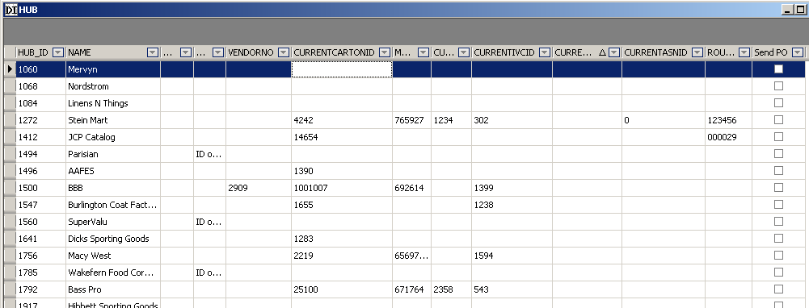

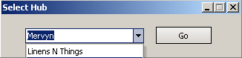

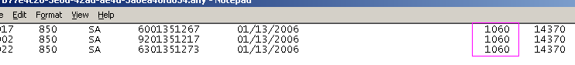
Functions:
  - public NameValueList HubList(string nodeName,string nodeValue ) in OleDbDatabaseName.cs (DII_DATABASE)
  - XML column in table HUB has addition element <COMMUNICATION> under <DIXML> the structure of this element looks like this:
<DIXML>
<COMMUNICATION>
<SENDDOCUMENT>850</SENDDOCUMENT>
<RECEIVEDOCUMENT></RECEIVEDOCUMENT>
<COMMUNICATION>
</DIXML>

Form Current Hub

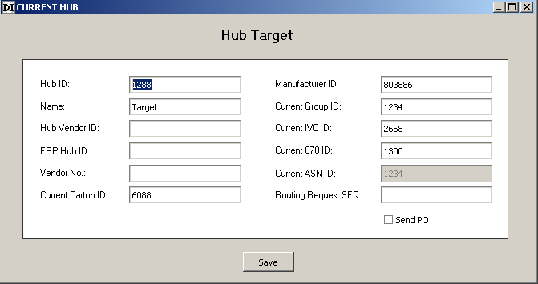

Form Item
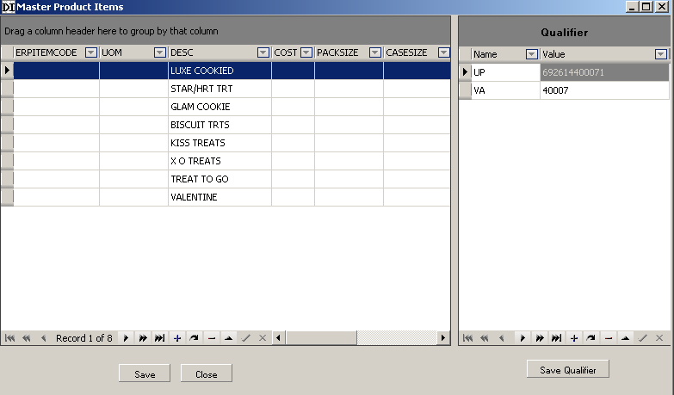

Form Product Item
If the active check box is checked, that item belongs to that hub.
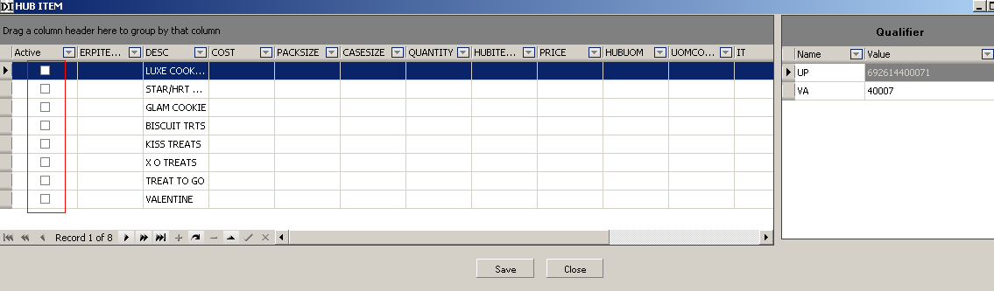
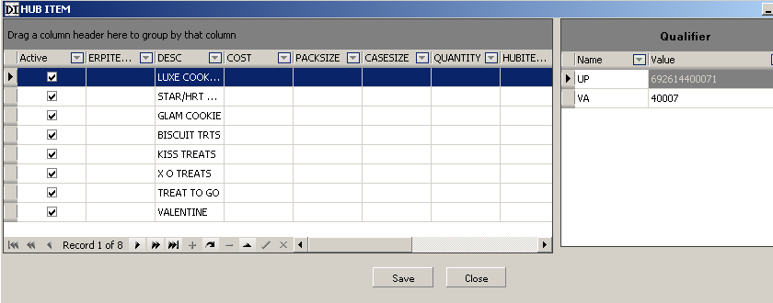

Store
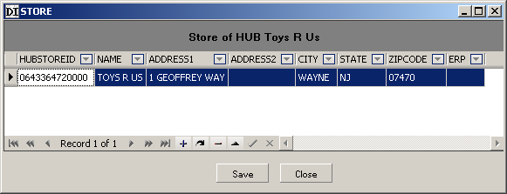

Quantity Available ODBC Connector
Quantity Available ODBC form allows users to set available quantity of their products between their inventory and DIintegrator.
Users need to setup DSN name for the file or database which contains information about quantity available of their products. Quantity Available ODBC form will also test the SELECT statement or UPDATE statement input by user. These statements are stored in XML format in DiiAppConfig.Xml

Inputs
- DSN name
- User ID/password if connect to database
- The select statement or update statement input by user

Processing
If the checkbox active is checked, the select or update statement is used in allocation wizard form to show actual quantity available from user. If not, allocation wizard form does not show actual available quantity from user.
Related class:
ODBCquantity.cs ((Dii_ModuleLoader)

User Interface
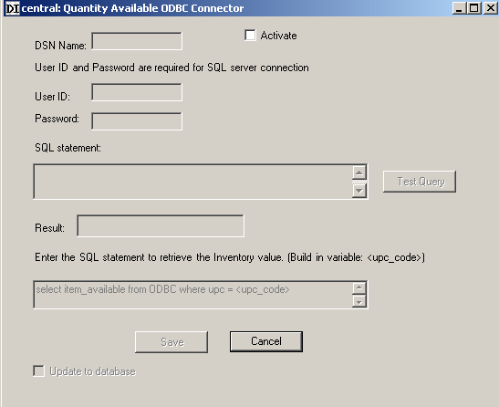

Default Value
Some data columns in some DOCs are turned around from other DOCs and also get information from default value. Default Value is stored in Mapfiles. When one DOC is transformed from another DOC, Default Value will be taken from Mapfiles.

Inputs: Mapfile

Processing:
Default Value from map file will be taken into document and that document is saved to Database.
PO
Invoice
Database
Create810 ()
GetDefaulValue
Save into
Default Value from DOC810Map.xml will be taken into Invoice and Invoice Data is saved to Database.
Rules:
- Default Value will not override existing value; Default Value is only taken if the field is empty.

- If customers want to override, they will have to use Auto-Fill to override the existing value if they want to

Outputs: document with default value is added.

Log
To log all the exceptions and errors in DII; This module also logs all the configuration and setting of the system on which the DII is running.

Flowchart
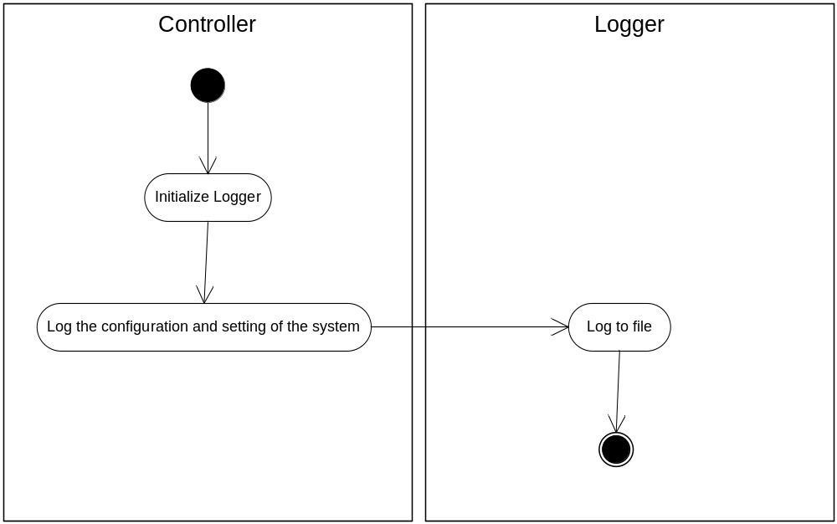

Functions

Log()
The functionality of this method is to write the log information to the log file as the defined format.

Inputs
The log information and exception (if any).

Processing
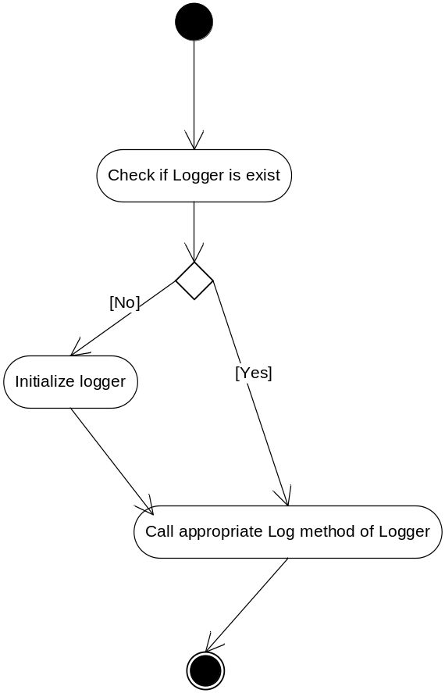

Outputs
The ASCII files as the defined format.

New Transactions
New Transactions shows new transactions of inbound data such as PO and 754 of all hubs. It’s a left bar panel which shows information of new POs and 754 for all the hubs that the user trades with. New PO means this PO has not been processed to create ASN or Invoice. Similarly, “New 754” means it has not been processed to create ASN.

Inputs
Information from dicofig.xml, information from table HUB (Diintegrator database)

Processing
- If hubId from diconfig exist in database and current Map.inf ➔ show that hub in new Transaction.
- If hubId from diconfig does not exist in database ➔ do not show that hub in new Transaction.

Outputs
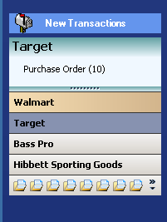

Communication
Communication module is used to transfer files between DIintegrator and FtpServer
Communication has 3 features:
- Upload
- Download
- Sync All (both upload and download)

Inputs
The following information from DiiAppConfig.xml
- DIftpAccount
- DIftpPassword
- InboxFolder
- FtpServerIP

Processing
Firstly, the program inside DIintegrator will decrypt DIftpPassword. After providing a correct path to ftp server and checking correct DIftpAccount and DIftpPassword, DI Connect Lite 2.01 form will popup for the user doing download or upload.

Outputs
Transferred files.

